
Wafi desing document


November 14, 2025
[W0504959]

Contents
Reflection 5
Animation 6
A floaty moon when the cursor hovers over it 6
How I did it ? 6
Why I did it? : 6
A fun easter egg where the moon grows bright and larger when user holds click for longer time 6
How did I do it ? 6
Why did I do it? : 6
Peer review 7
COMMENTS RECEIVED 7
Comments made to other students 8

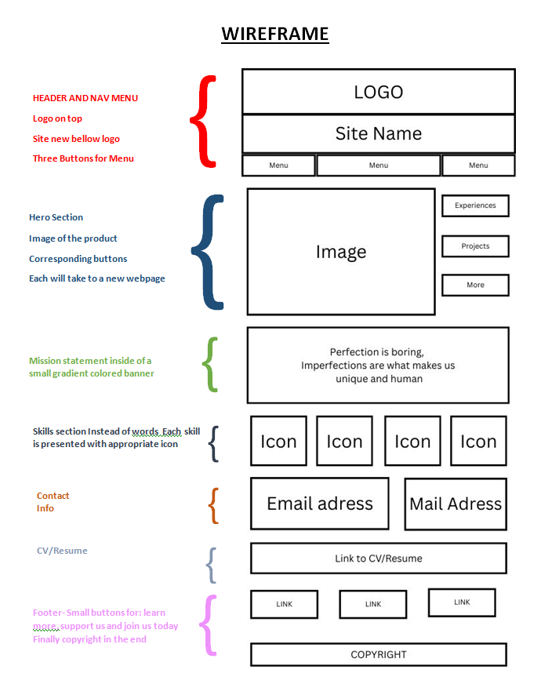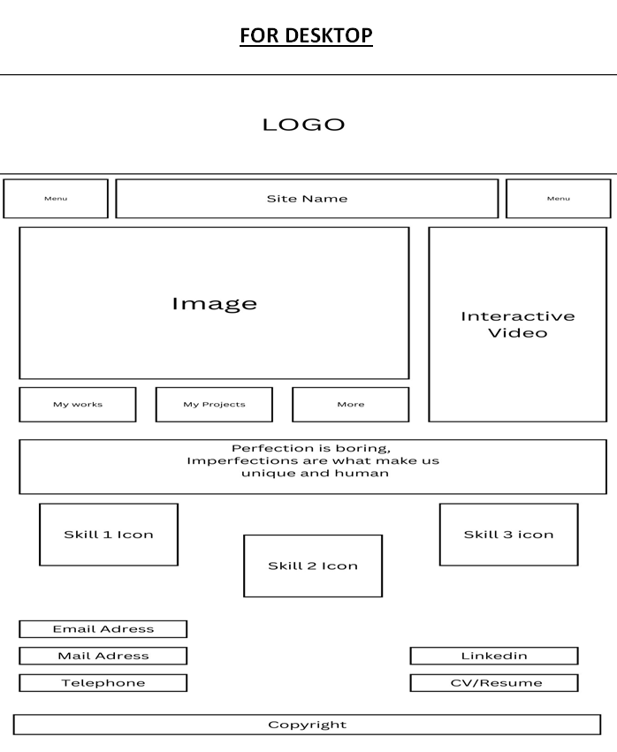

Reflection
The wireframe of my mobile is very similar to what I had envisioned. The header and nav menu are exactly how I wanted them. However, it’s not a 1:1 match with the wireframe. I made some changes, for example: I removed the extra menu buttons, put the resume in a separate container, and moved the contact info to the footer.
The reason for these changes is that when I made the wireframe, I didn’t yet know the power of CSS. I was working only with the HTML knowledge I had at the time. As I completed more practical assignments, I gained a deeper understanding of web design.
Looking back at my desktop wireframe, it feels overly complex and overcrowded. Let’s be honest, no one likes that in a website. A good site should catch the eye with smart balance (like the 60-20-10 rule), playful buttons, or engaging menus.
What I’ve learned is that wireframes aren’t the destination, they’re a roadmap. Sometimes a messy wireframe is all I need to unlock the real potential of my site. They’re guiding lines, not final rules. We overshoot, and that’s okay — because as we build, we see what’s too much, what’s missing, and we fix it in the moment.

Animation

I did two user-triggered animation for my website-

A floaty moon when the cursor hovers over it

How I did it ?
I used @keyframes to move the moon image up and down like for the hover
I set the float animation to 2 second ease-in-out and infinite so it loops smoothly and doesn’t stop
Applied using .moon-hover:hover

Why I did it? :
Initiates users to fiddle more with it
Subtle and fun way of website interactivity while also matching the theme of the website

A fun easter egg where the moon grows bright and larger when user holds click for longer time

How did I do it ?
I used :active state with @keyframes pulse, most importantly I used cubic-bezier() which is a function that helps with the smooth spring effect its better and more convenient than using just ease-in ease-out or liner etc. transform scale (2.5) makes it grow 2.5 times and then I used some design to add a glow i.e. filter:brightness(2)

Why did I do it? :
It’s a fun secret easter egg because it’s not that obvious user needs to click and hold it. Albeit for a very miniscule amount of time but the trick is that the tiny jiggle or small growth it does will make the user feel unamused or just move on from it but if they are curious even they would click and hold it to find a big lunar glow on their screen

Peer review

COMMENTS RECEIVED

Comment from: | Comment | Accept/Reject | Rationale
Zahara | The moon color is cool + the small moon animation but the font of the body is not readable | Accept | This is true ,the header of the font is already not readable because of the property of the font itself and that makes the body text of it even more jittery and hard to read. I will swap the font to something that matches what I envision- something that gives futuristic vibes but is readable
Hui Yui | Overall good but the change the font color | Reject | I understand that the font itself isn’t readable, but the color is intentional. The color of the font “neon-Ish purple” is a property of the font itself which is the reason I chose it and I think it fits well with the gray-ash background topped with the red buttons and slick white lines of my webpage. But I do agree about the font being a bit unreadable.
Josh | Good foundation but the font has low readability | Accept | Again, I agree with Josh because I leaned too much into personal choices rather than understanding the perspective of what others might think of it. To me, the font felt futuristic because of the purple color and dashed gaps and glitch-like green specks, but it’s reading as jittery and hard to scan not the clean cyberpunk vibe I envisioned. So, I will swap my font with a font that is readable and pretty not just to me but to choose it considering everyone else.

Comments made to other students

This page is for comments you have made to other students.
Comment made to: | Comment:
Josh | Good skeleton but more CSS elements are missing . background colors need a bit more depth and padding on text, so it doesn’t sharply pop out too much- but overall, good
Hui Yui | It’s beautiful and very broad/expensive. I find her color scheme nice because it blends in well with the theme of the website
Maria | The colors are nice, its eye catching. I love the front page which is a background with a bit of tint or translucent property which makes the text on top of it really catch the eye. The rest of the webpage is also well put together.
Zahara | Really bold and to the point website as it matches the theme. I find the body and the lower section of the website to be very similar Ish in color, so it does blend but looks a bit off in my eyes. Overall, a really good website with its foundation and CSS elements.

